Experiment :-4

Problem statement:-
Implement error detection and correction mechanisms using block coding and Cyclic Redundancy Check (CRC). Simulate a communication system in Cisco Packet Tracer to demonstrate how errors are detected and corrected during data transmission.

Aim:- Error Detection and Correction Mechanisms Using Block Coding and CRC

Procedure:-

Step 1: Open Packet Tracer
- Launch Cisco Packet Tracer
- Go to File > New

Step 2: Add Devices to Workspace
From the bottom device panel:
- Add 2 PCs - Click "End Devices" category - drag 2 PC icons to workspace
- Add 1 Switch - Click "Network Devices" - "Switches" - drag 2960 switch to workspace
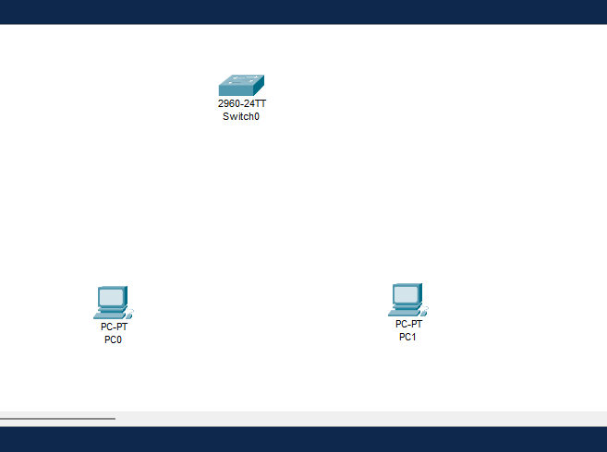

Step 3: Connect the Devices
- Select Connections tool (lightning bolt icon)
- Choose Copper Straight-Through cable
- Click PC0 - select FastEthernet0 port
- Click Switch - select FastEthernet0/1
- Repeat: Connect PC1 - Switch FastEthernet0/2
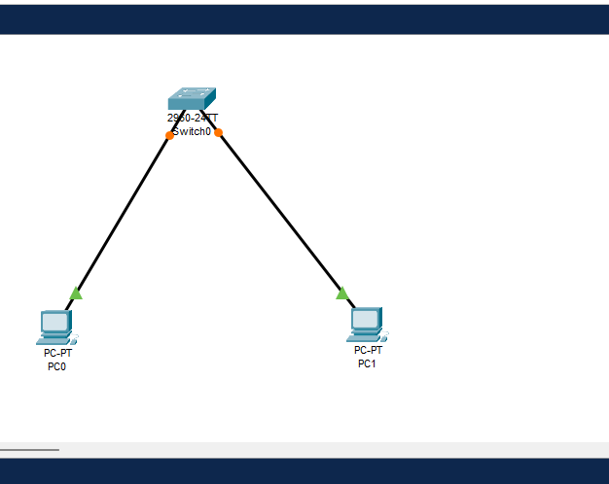

Step 2: Configure IP Address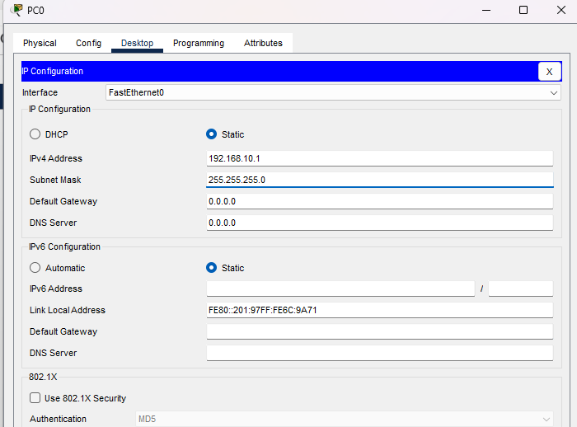

Step 7: Send a Simple PDU (Ping)
- Click the envelope icon on the toolbar -"Add Simple PDU"
- Click on PC0 (source)
- Click on PC1 (destination)
- You'll see a packet animation - this simulates data transmission
- Check the PDU List window at the bottom — it should show "Successful

